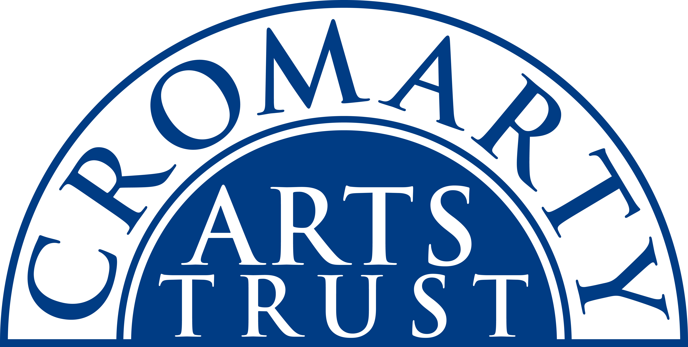
2025 BOOKING FORM

YOUR DETAILS (all information is kept in confidence)

Name & Age of Participant
Address
Postcode

Landline & Mobile

Email
Please let us know of any mobility, dietary or other issues that would be useful for us to be aware of?

WORKSHOP / COURSE DETAILS

Name | Screen Printing Kids AGED 8+ Workshop
Date | Sunday 6th April 2025 09.30am-1.30pm
Total Cost | £25
Venue | The Stables, Causeway, Cromarty IV11 8XS
Where did you hear about this course?

Please note:
- You should bring a packed lunch & some water.
- Arrive in plenty of time, at least 15 mins before the advertised start.
- Bring a T shirt!

Please tick this box once you have paid by BACS to:
Cromarty Arts Trust, Bank of Scotland, Account 00911502, Sort Code: 80 06 83 with ref Printing KIDS

Please return this completed form by email to info@cromartyartstrust.org.uk or post to Ardyne, 19 Bank St, Cromarty, IV11 8YE
We look forward to seeing you on the Screen printing course.

