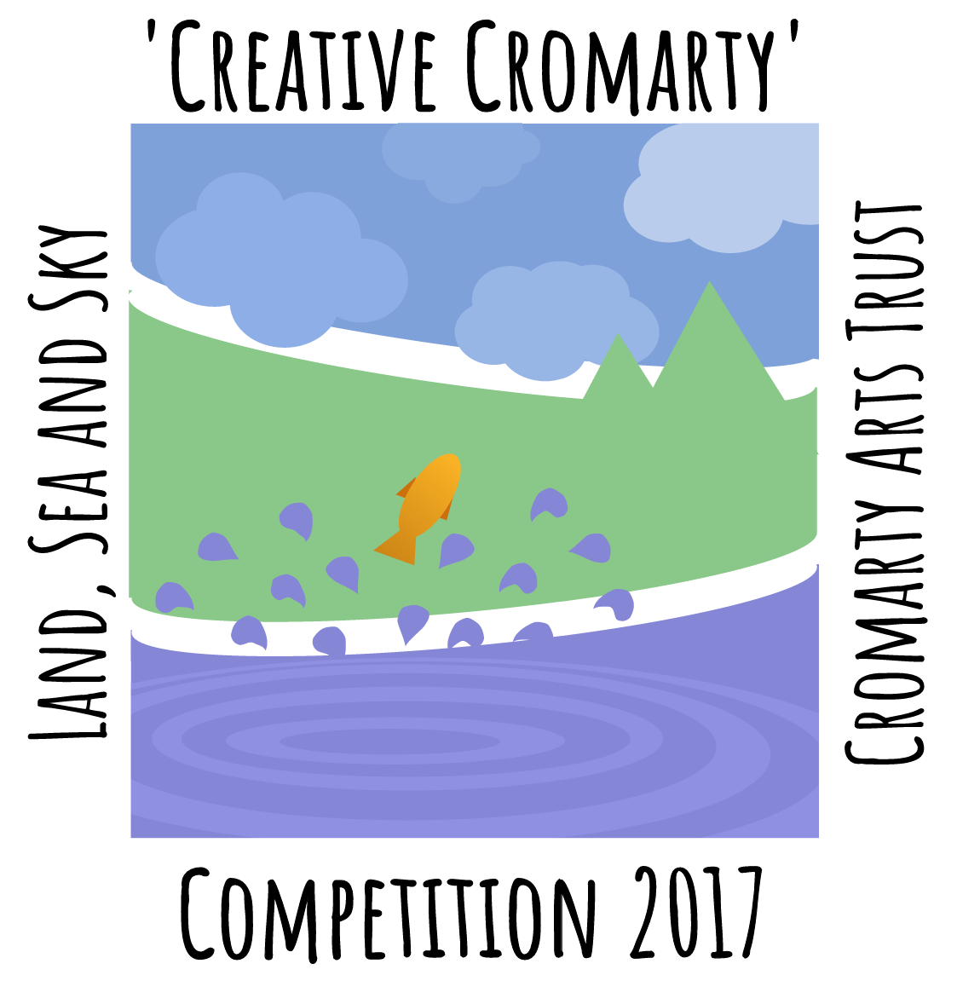
‘Creative Cromarty’ Competition 2017
Cromarty Arts Trust
Cromarty Arts Trust (CAT) is looking for local creative NON- PROFESSIONAL people to create a piece(s) of art work for the ‘Creative Cromarty’ Competition 2017. This year’s theme is nature: The ‘LAND, SEA and SKY’.
We are only accepting entries from people within the Fortrose Academy Catchment Area that can be found on: http://www.arcgis.com/apps/webappviewer/index.html?id=531a30ee33564231866ff94e96607f26
There are three categories in which people can enter: Primary School Pupils, Adults (Anyone over age of 11) and a separate Photography category which incorporates all ages. The piece(s) of work can take any form of visual art from painting to sculpture to tapestry or drawing etc...
There is a maximum number of 3 entries and these entries can be in both your age category and the photography category (that is open to all ages) separately.
All submissions must be received by Monday 18th December @ 5:00pm at can be taken to Ardyne, 19 Bank Street, Cromarty, The Black Ilse, Ross-shire, IV11 8YE that is open from 9am-4pm Monday to Thursday.
The work will be exhibited on the 6th and 7th January at the end of the competition for the public to come and view in the CAT Stables Building.
The winners from each category will receive, for a year, a beautiful, one-of-a-kind, hand-crafted, wooden trophy made by local artist James Flavell, press coverage and a certificate of achievement from the Cromarty Arts Trust. Winners will also be recognised in the ‘Creative Cromarty’ Hall of Fame on the CAT website.
Submission forms and all terms and conditions can be found at: www.cromartyartstrust.org.uk/workshops-and-classes_creative-cromarty-competition.asp
Joe Inman,
Intern, Cromarty Arts Trust

