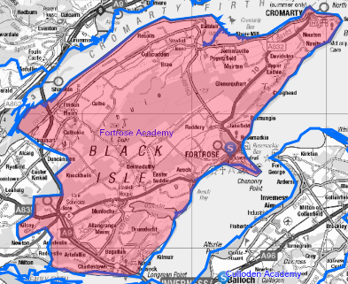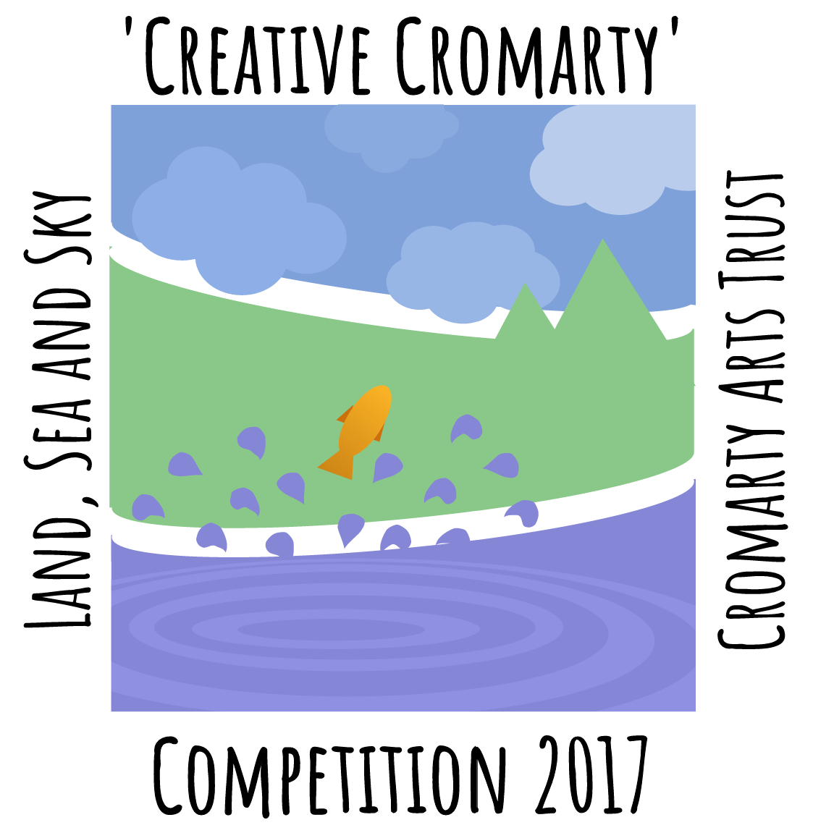

**Participant Details**

Address Must fall within the Fortrose Academy Catchment Area found here:

[**https://goo.gl/Hj7vxu**](https://goo.gl/Hj7vxu)

PLEASE TURN OVER

School (if applicable)

Parent/Guardian Phone number (if under 16 )

Contact Number

Email

Parent/ Guardian Signature (if under 16y)

Address

Date of Birth (dd/mm/yy)

**Creative Cromarty Competition**

Name



Tick to agree to all terms and condition of the competition . Full terms and conditions can be found at: [**www.cromartyartstrust.org.uk/workshops-and-classes_creative-cromarty-competition.asp**](http://www.cromartyartstrust.org.uk/workshops-and-classes_creative-cromarty-competition.asp)

Tick to sign up to the twice monthly Cromarty Arts Trust E-news and to be updated about future events

**Background Info or story on your submission, e.g. your inspiration; subject location, reason for choosing this, feelings evoked, challenges encountered, etc...**

**Submission 1**

**(If Applicable)**

Category

Primary School/ Adults (Over 11) / Photography

Secondary Category

Title of Submission

Land/ Sea / Sky

Media

**Background Info or story on your submission, e.g. your inspiration; subject location, reason for choosing this, feelings evoked, challenges encountered, etc...**

Size (cm)

Category

Primary School/ Adults (Over 11) / Photography

Secondary Category

Title of Submission

Land/ Sea / Sky

Media

Size (cm)

Category

Primary School/ Adults (Over 11) / Photography

Secondary Category

Title of Submission

Land/ Sea / Sky

Media

Size (cm)

**Background Info or story on your submission, e.g. your inspiration; subject location, reason for choosing this, feelings evoked, challenges encountered ,etc...**

**Submission 2 (If Applicable)**

**Submission 3**

**(If Applicable)**

**(If Applicable)**