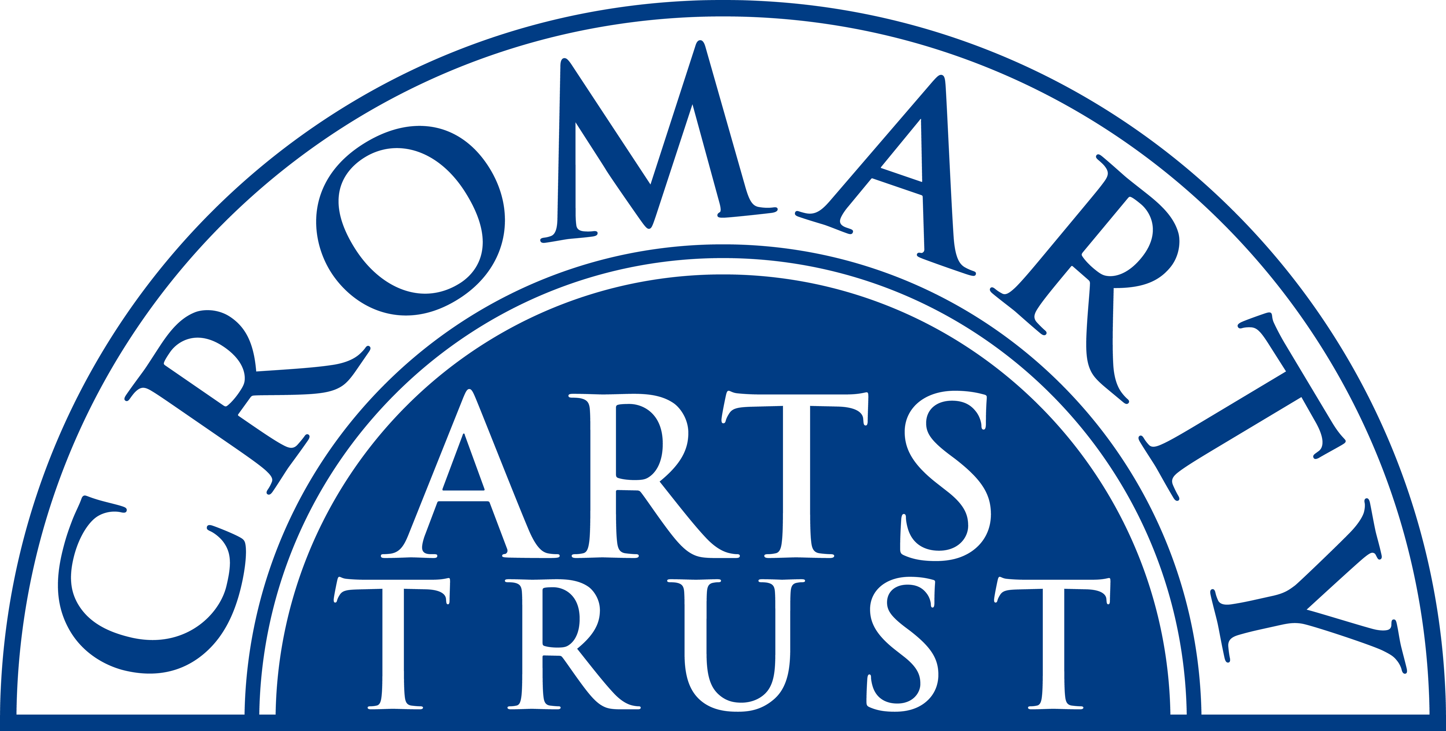
2025 BOOKING FORM

YOUR DETAILS (all information is kept in confidence)

Name of Participant
Address
Postcode

Landline & Mobile

Email
Please let us know of any mobility, dietary or other issues that would be useful for us to be aware of?

WORKSHOP / COURSE DETAILS

Name | Strictly Come Dancing lesson – Jive with James
Date | Saturday 10 May 2025 2-4pm
Total Cost | £20
Venue | The Stables, Causeway, Cromarty IV11 8XS
Where did you hear about this course?

Please note:
- You should wear comfortable shoes and bring some water.
- Arrive in plenty of time, at least 15 mins before the advertised start.

We now require payment to secure your place. Please tick this box once you have paid by BACS to:
Cromarty Arts Trust, Bank of Scotland, Account 00911502, Sort Code: 80 06 83 with ref JIVE

You can read our cancellation policy on our website at www.cromartyartstrust.org.uk/the-trust

Please return this completed form by email to info@cromartyartstrust.org.uk or post to Ardyne, 19 Bank St, Cromarty, IV11 8YE

We look forward to seeing you at the class.

