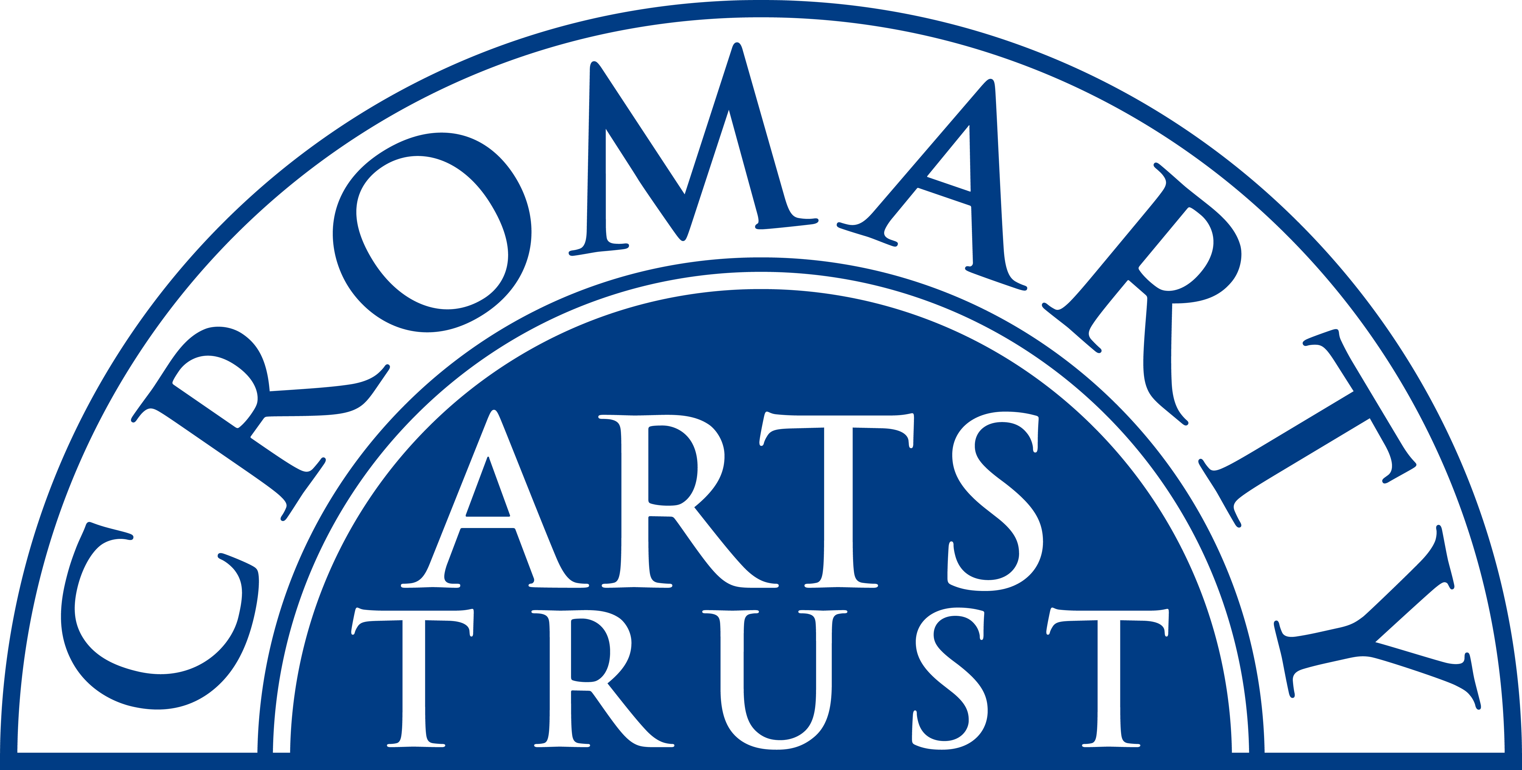
2025 BOOKING FORM

Name of Participant
Address
Landline & Mobile

Email
Any mobility, allergy, or other issues that we should be aware of?

WORKSHOP / COURSE DETAILS

Name | Make a clay toad and toad house.
Date | Saturday 8 March 2025  2-4pm
Total Cost | £15
Venue | The Stables, Cromarty

Please note:
- Arrive 15 mins before the advertised start.
- Your finished pottery will be fired and ready to collect by 24 March.

Please return this form and wait until we have told you that you have a space before you pay £15 by bank transfer to: Cromarty Arts Trust, Bank of Scotland, Account 00911502, Sort Code: 80 06 83 with ref TOAD.

Cancellations
If you have to cancel we will do our best to fill your space and refund you, however this is not always possible and we appreciate your understanding in this matter.

Please return this completed form by email to info@cromartyartstrust.org.uk or post to Ardyne, 19 Bank St, Cromarty, IV11 8YE or call 01381 600354 in business hours.

