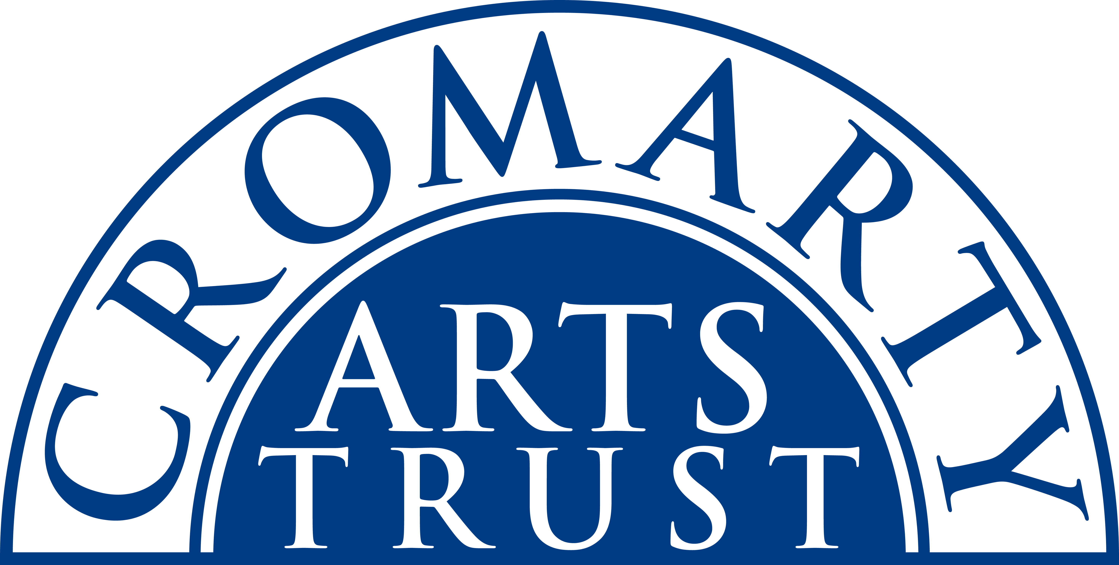
2024 BOOKING FORM

YOUR DETAILS (all information is kept in confidence)

Name of Participant
Address
Postcode

Landline & Mobile

Email
Please let us know of any mobility, dietary or other issues that would be useful for us to be aware of?

WORKSHOP / COURSE DETAILS

Name | Sewing Bring your own Project.
Date | Saturday 2nd & Sunday 3rd November 2024 10.00am- 4.30pm
Total Cost | £115
25% Deposit payable on booking | £28.75
Venue | The Old Brewery Café, Burnside Place, Cromarty IV11 8XQ
Where did you hear about this course?

Please note:
- You should bring a packed lunch both days.
- Arrive in plenty of time, at least 15 mins before the advertised start.
- Please let us know if you need to borrow a sewing machine.

We now require a 25% deposit to secure your place. Please tick this box once you have paid by BACs to:
Cromarty Arts Trust, Bank of Scotland, Account 00911502, Sort Code: 80 06 83 with ref Sewing BYOP

The balance for your course will be invoiced and due approximately one month prior to the start date.

Please return this completed form by email to info@cromartyartstrust.org.uk or post to Ardyne, 19 Bank St, Cromarty, IV11 8YE
We look forward to seeing you on the Bring your own Project course.

