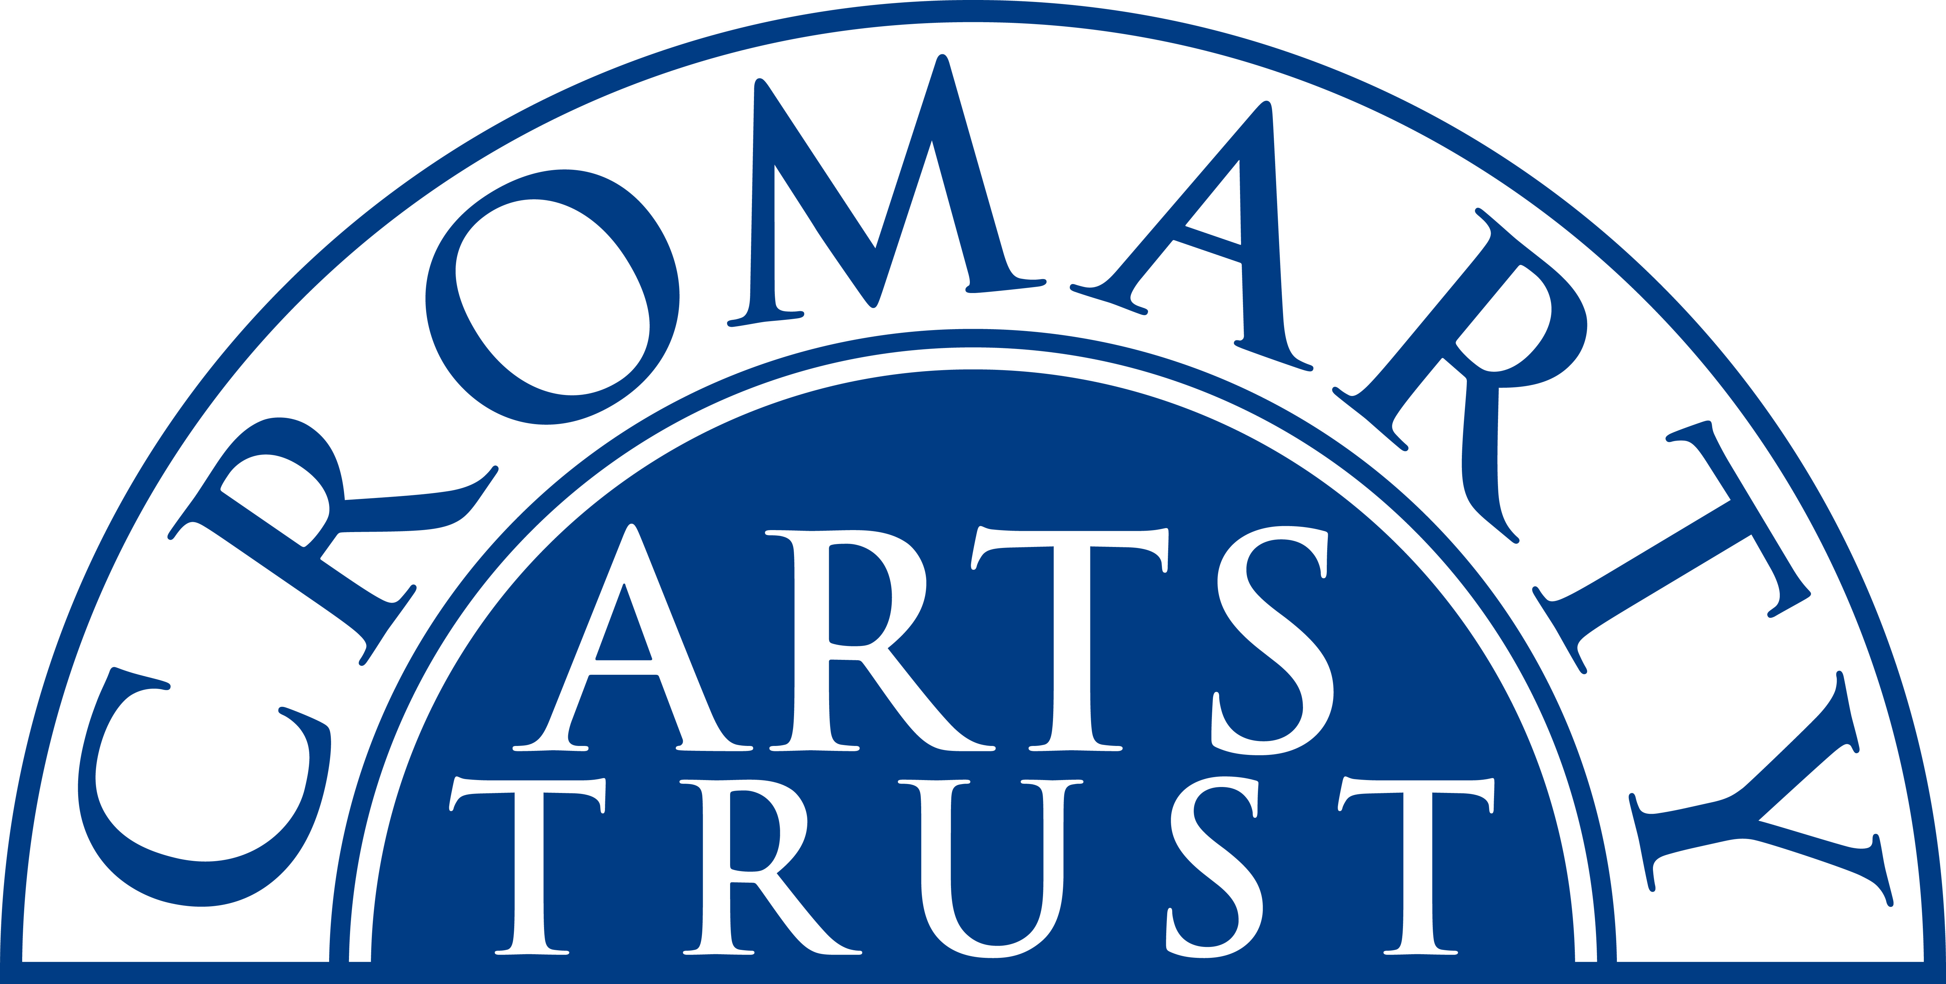
2025 BOOKING FORM

YOUR DETAILS (all information is kept in confidence)

Name of Participant
Address
Postcode

Landline & Mobile

Email
Please let us know of any mobility, dietary or other issues that would be useful for us to be aware of?

WORKSHOP / COURSE DETAILS

Name | Landscape Painting Weekend.
Date | Saturday 6 & Sunday 7 September 2025 10.00am- 4.30pm
Total Cost | £160
25% Non-refundable deposit payable on booking | £40
Venue | Outdoors and at The Stables, Cromarty IV11 8XS
Where did you hear about this course?

Please note:
- You should bring a packed lunch both days, and some water.
- Arrive in plenty of time, at least 15 mins before the advertised start.
- An Art Material List will be emailed to you in June.

We now require a 25% deposit to secure your place. Please tick this box once you have paid the deposit by BACs to: Cromarty Arts Trust, Bank of Scotland, Account 00911502, Sort Code: 80 06 83 with ref LANDSCAPES

You can read our cancellation policy on our website at www.cromartyartstrust.org.uk/the-trust

The balance for your course will be invoiced and due approximately one month prior to the start date.

Please return this completed form by email to info@cromartyartstrust.org.uk or post to Ardyne, 19 Bank St, Cromarty, IV11 8YE.
We look forward to seeing you on the sewing course.

