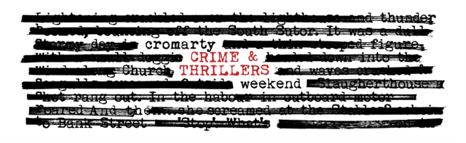
2 – 5 May 2025
Booking Form (non-residential)

Name(s): ________________________________________________________________________________

Tel/Mobile: _______________________ Email: ___________________________________________

Please write the number of tickets required in the last column. If you are booking lunch please advise of allergies and/or dietary requirements here. ___________________________________________

FRIDAY 2 May | When | Where | Price | Number of tickets
Crime & Thrillers Quiz | 8.00 – 10pm | Old Brewery | £5

SATURDAY 3 May
Dr Suzie Edge | 9.30 – 10.30am | Victoria Hall | £15
James Oswald & Rob Parker | 11.00 – 12.30pm | Victoria Hall | £15
BUFFET LUNCH | 12.45 – 1.30pm | Old Brewery | £16.50
Denise Mina & David Greig  The Darkland Tales | 2.00 – 3.30pm | Victoria Hall | £15
Cristopher Brookmyre & Marisa Haetzman as Ambrose Parry | 4.00 – 5.30pm | Victoria Hall | £15
Mull Historical Society – Live Music  ‘In My Mind There is a Room’ | 8.00 – 9.30pm | Victoria Hall | £12

SUNDAY 4 MAY
Ian Rankin interviewed by  Colin MacIntyre | 10.00 – 11.30am | Victoria Hall | £15
Dr Maria Maclennan | 12.00 – 1.00pm | Victoria Hall | £15
BUFFET LUNCH | 1.30 – 2.30pm | Old Brewery | £16.50

MONDAY 5 MAY for ages 8+
The Mystery of the Missing Macaroni Pies – Children & Young People Day  Your age: _________________________ | 10.00 – 4.00pm | Old Brewery | £20  IV11 postcodes £5

All six author talks on Saturday & Sunday | £85
TOTAL | £

I’ve made my payment of £_______________ by BACs or Cheque (delete as appropriate).
Bank of Scotland, Acc: 00911502, Sort Code: 80-06-83 (ref Crime).
Cheques payable to ‘Cromarty Arts Trust’

Now email or post this form to: info@cromartyartstrust.org.uk
The Cromarty Arts Trust, Ardyne, 19 Bank Street, Cromarty, IV11 8YE

Call us on 01381 600354 if you have any queries.

www.cromartyartstrust.org.uk

