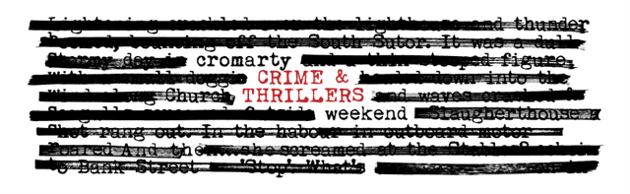
2 – 4 May 2025
Residential Booking Form
The ‘Full Sentence’ Package £290

Name(s): ____________________________________________________________________________________

Tel/Mobile: _____________________ Email: _______________________________________________

Please advise us of any allergies or dietary requirements: ______________________________________

FRIDAY 2 May | When | Where
Welcome Drinks & Dinner | 6pm | Old Brewery
Crime & Thrillers Quiz | 8.00 – 10pm | Old Brewery

SATURDAY 3 May
Dr Suzie Edge | 9.30 – 10.30am | Victoria Hall
James Oswald & Rob Parker | 11.00 – 12.30pm | Victoria Hall
BUFFET LUNCH | 12.45 – 1.30pm | Old Brewery
Denise Mina & David Greig  The Darkland Tales | 2.00 – 3.30pm | Victoria Hall
Cristopher Brookmyre & Marisa Haetzman as Ambrose Parry | 4.00 – 5.30pm | Victoria Hall
DINNER | 6.30pm | Old Brewery
Mull Historical Society – Live Music  ‘In My Mind There is a Room’ | 8.00pm | Victoria Hall

SUNDAY 4 MAY
Ian Rankin interviewed by  Colin MacIntyre | 10.00 – 11.30am | Victoria Hall
Dr Maria Maclennan | 12.00 – 1.00pm | Victoria Hall
BUFFET LUNCH | 1.30 – 2.30pm | Old Brewery

I’ve made my payment of £_______________ by BACs or Cheque (delete as appropriate).
Bank of Scotland, Acc: 00911502, Sort Code: 80-06-83 (ref Crime).
Cheques payable to ‘Cromarty Arts Trust’

Now email or post this form to: info@cromartyartstrust.org.uk
The Cromarty Arts Trust, Ardyne, 19 Bank Street, Cromarty, IV11 8YE

Call us on 01381 600354 if you have any queries.

