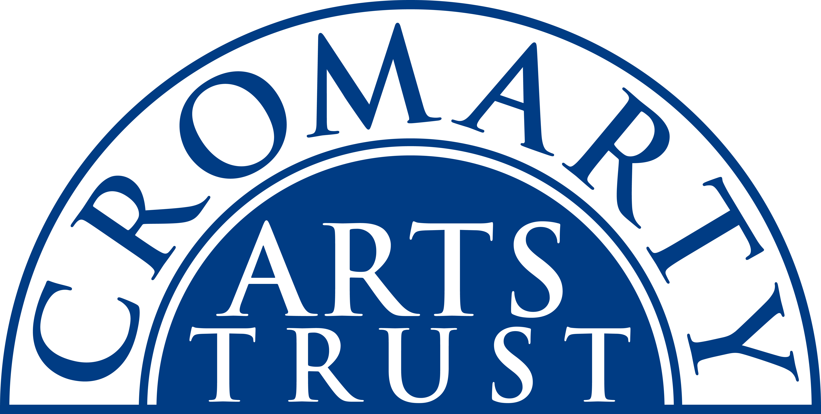
Cromarty Harp Village - Application Form
20-22 September 2024
Name: _______________________________________________________
Address: _______________________________________________________________________________
____________________________________________________________ Postcode: _________________
Tel/Mobile: ____________________________ Email: __________________________________________
Any special dietary requirements and/or other issues it would be useful for us to know about: ______________________________________________________________________________
The Cromarty Harp Village is a two-day residential weekend of music in the beautiful surroundings of the Old Brewery in the vibrant, coastal Highland town of Cromarty. There are workshops all day on Saturday and Sunday run by Corrina Hewat, Cheyenne Brown and Heather Yule suitable for all but beginner level.

Please indicate the events you will be attending:

Full Residential package: B&B accommodation on Friday 20 & Saturday 21 Sept at the Old Brewery; welcome drinks & dinner on Fri; Tutors playing on Fri; drinks & dinner and massed playing session on Sat night; lunches on Sat & Sun; 6 x workshops (3 on Sat, 3 on Sun). | £305
Non-Residential package: includes all of the above except B&B | £215

Individual Bookings if you are NOT taking either of the packages above:

Workshop 1 Saturday 9:30 – 11:00 | £20
Workshop 2 Saturday 11:30 – 13:00 | £20
Workshop 3 Saturday 14:30 – 16:00 | £20
Workshop 4 Sunday 9.30 – 11:00 | £20
Workshop 5 Sunday 11:30 – 13:00 | £20
Workshop 6 Sunday 14:15 – 15:45 | £20
Saturday Lunch 13:15 – 14:00 | £16.50
Sunday Lunch 13:15 – 14:00 | £16.50

Please indicate your ability level, contact us if you’re not sure:
Lower Elementary | Upper Elementary | Intermediate/Advanced

IMPORTANT - Please tick here if you require us to supply a harp for you:
Please make sure you have ticked everything you want to attend and post or email this form to:
The Cromarty Arts Trust, Ardyne, 19 Bank Street, Cromarty, The Black Isle, IV11 8YE
Tel: 01381 600354 Email: info@cromartyartstrust.org.uk
I’m paying £…………… by BACS (ref HARPS). Bank of Scotland, Acc No: 00911502 / Sort Code: 80-06-83
I’m paying £……………. by cheque payable to ‘Cromarty Arts Trust’

