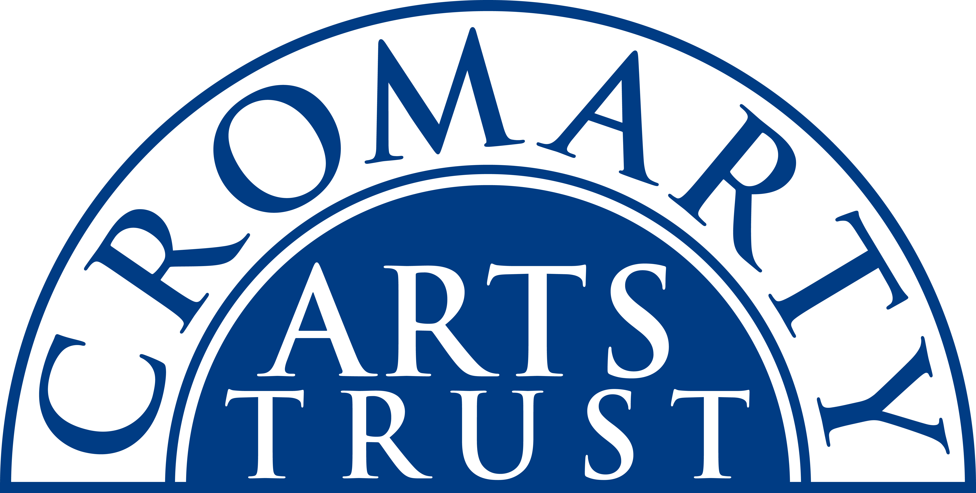
2025 BOOKING FORM

YOUR DETAILS (all information is kept in confidence)

Name of Participant
Address
Postcode

Landline & Mobile

Email
Please let us know of any mobility, dietary or other issues that would be useful for us to be aware of?

WORKSHOP / COURSE DETAILS

Name | Stone Letter Carving Taster Weekend
Date | Saturday 28 & Sunday 29 June - 09.30am-5pm
Total Cost | £180
25% Non-Refundable Deposit payable on booking | £45
Venue | The Stables, Causeway, Cromarty IV11 8XS
Where did you hear about this course?

Please note:
- You should bring sturdy footwear & protective goggles.
- Arrive in plenty of time, at least 15 mins before the advertised start.
- All materials & tools including your piece of stone to take home will be provided.

We now require a 25% deposit to secure your place. Please tick this box once you have paid by BACs to:
Cromarty Arts Trust, Bank of Scotland, Account 00911502, Sort Code: 80 06 83 with ref Stones.

The balance for your course will be invoiced and due approximately one month prior to the start date.
You can read our cancellation policy on our website at www.cromartyartstrust.org.uk/the-trust

Please return this completed form by email to info@cromartyartstrust.org.uk or post to Ardyne, 19 Bank St, Cromarty, IV11 8YE
We look forward to seeing you on the Stone letter Carving course.

