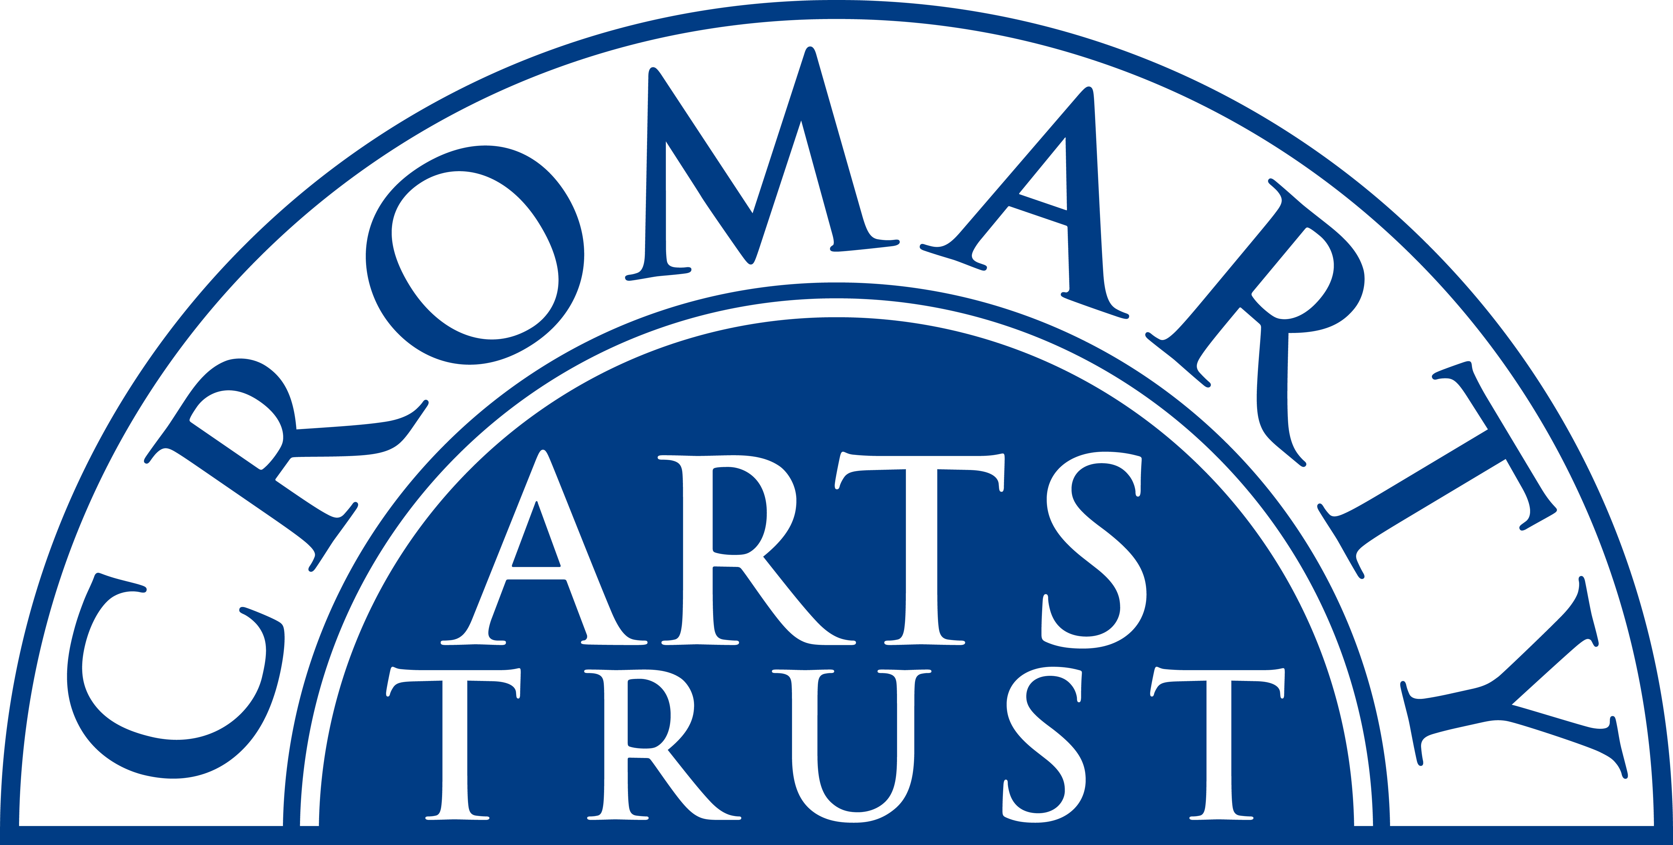
2024 BOOKING FORM

YOUR DETAILS (all information is kept in confidence)

Name of Participant
Address
Landline & Mobile

Email
Please let us know of any mobility issues or severe allergies.

WORKSHOP / COURSE DETAILS

Name | Collected Worlds - Assemblage and Drawing Workshop
Date | Sat 9 November 2024  9.30am – 1.30pm
Total Cost | £35
25% Non-refundable deposit payable on booking | £8.75
Venue | The Stables, Causeway, Cromarty IV11 8XS
Where did you hear about this course?

Please bring:
Bring at least one box (two recommended). Shoe box size or smaller.
Collected objects that fit into your box (see website for details)
Sketchbook A4 or A3
Paintbrushes for ink drawings
Graphite pencils if you wish to use instead of charcoal
Eraser

We now require a 25% deposit to secure your place. Please tick this box once you have paid by BACs to:
Cromarty Arts Trust, Bank of Scotland, Account 00911502, Sort Code: 80 06 83 with ref COLLECT

The balance for your course will be invoiced and due approximately one month prior to the start date.

Please return this completed form by email to info@cromartyartstrust.org.uk or post to Ardyne, 19 Bank St, Cromarty, IV11 8YE. We look forward to seeing you on the course.

